Payment backlogs

Payment practices report – User manual
Version 1.05.

Table of contents
1. Product description 3
1.1. Technical requirements 3
1.2. Package content 3
2. Product configuration 3
2.1. Configuration parameters - /n/SNPZP/ZPC 4
2.2. Configuration parameters - /n/SNPZP/ZPFC 6
2.3. Authorization objects 8
3. Transactions and programs 10
3.1. Document selection 11
3.2. Document analysis 15
3.3. Save to database 20
3.4. Statements conjunction 21
3.5. Loading Excel/TXT files 23
3.6. Tips & Tricks 28

Product description
Payment practices report is a proprietary product prepared by SNP and is intended to assist users in the preparation of a payment practices report directly in the SAP system and generating it as a file for electronic dispatch.

Technical requirements

Minimum requirements: SAP ECC 6.0., component version SAP_ABA >= 702.

Package content

The SNP product has been developed in a separate namespace /SNPZP/ZP.
It is provided as files that contain transports with a base solution that need to be imported into the Customer SAP system.
The solution can be customized to meet the client’s individual needs.

The tool consists of the following transactions:

Transaction ID | Transaction description
/n/SNPZP/ZPC | Payment backlogs – configuration
/n/SNPZP/ZPFC | Loading Excel/TXT files – validating configuration
/n/SNPZP/ZP | Payment backlogs report
/n/SNPZP/ZPF | Loading Excel/TXT files

Product configuration
The tool is configured using transactions:
/n/SNPZP/ZPC and /n/SNPZP/ZPFC

Configuration parameters - /n/SNPZP/ZPC

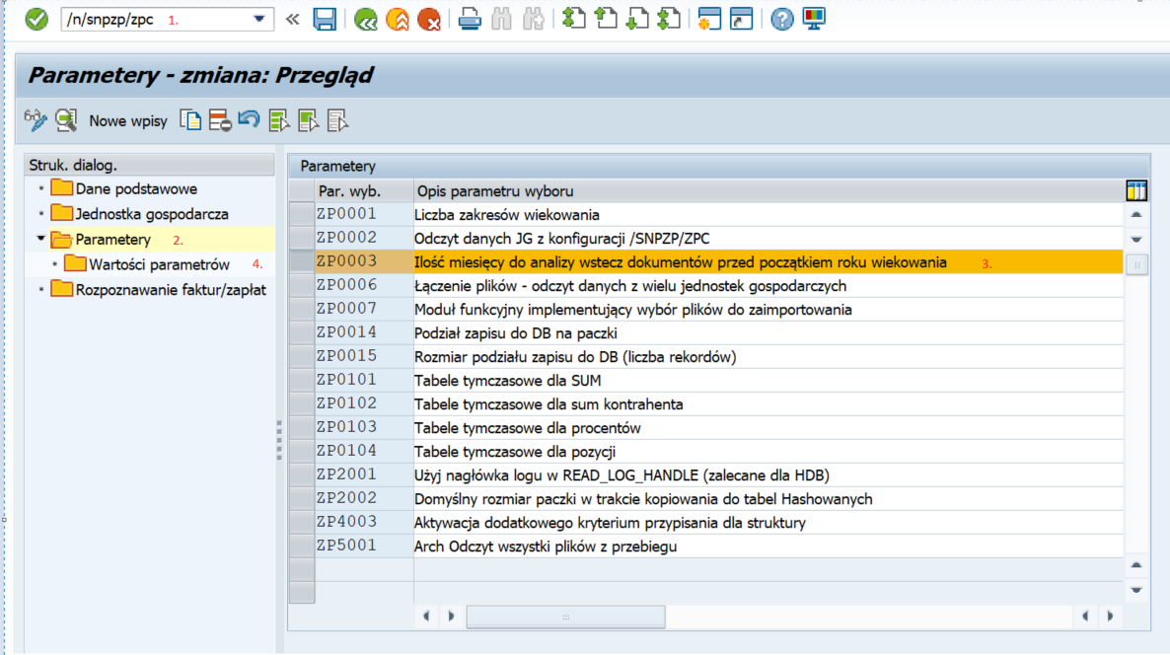

The ‘Ilość miesięcy do analizy wstecz dokumentów, przed początkiem roku wiekowania’ parameter is available in the configuration settings (/snpzp/zpc). If the value is not defined, 12 months are accepted by default (i.e., in addition, the entire calendar year prior to the aging date). The default value for the start of document analysis is displayed on the selection screen (in the example, the aging date is in 2020 and the parameter is defined in 6 months).

There is also a possibility to edit this date.

Once the edit option is disabled, returns the default value calculated from the configuration and aging date.

The edit function may be useful, for instance, when there are contractors with more than average payment arrears. For those contractors, it is possible to define a more distant date for document analysis and apply the default analysis range to the others at the same time (as excessive extension of the documents to be analyzed range may increase the preparation time of the report or even make it impossible to prepare such report).

The source of the accounting data in the report are the posted items in the recipient and suppliers accounts. The program looks for the dependencies between the posted documents starting with the invoice, through the payment reference documents. The position recognition is based on the configuration and more precisely – the definition of document types for invoices and payments (TYPE = document type). Without completing the configuration, the data will not be selected from the system.
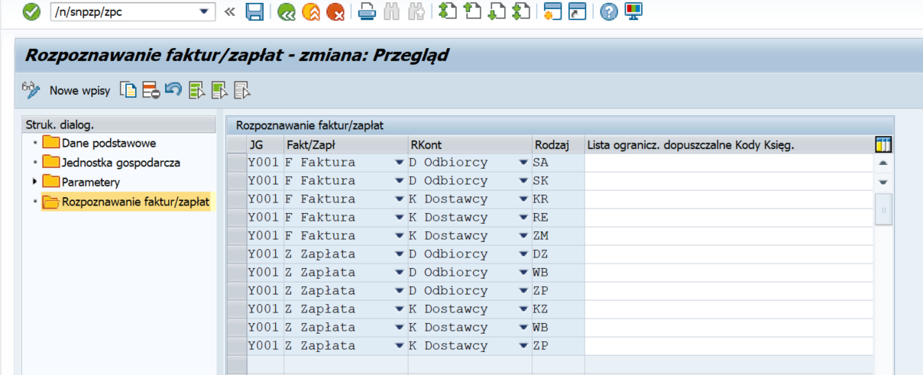

The user can configure the same document type as invoice and payment, using the appropriate posting codes and entering them in the column ‘Lista ogranicz.dopuszczalne Kody Ksieg’ by separating them with any sign, f.i.: ‘,’ or ‘;’, etc.

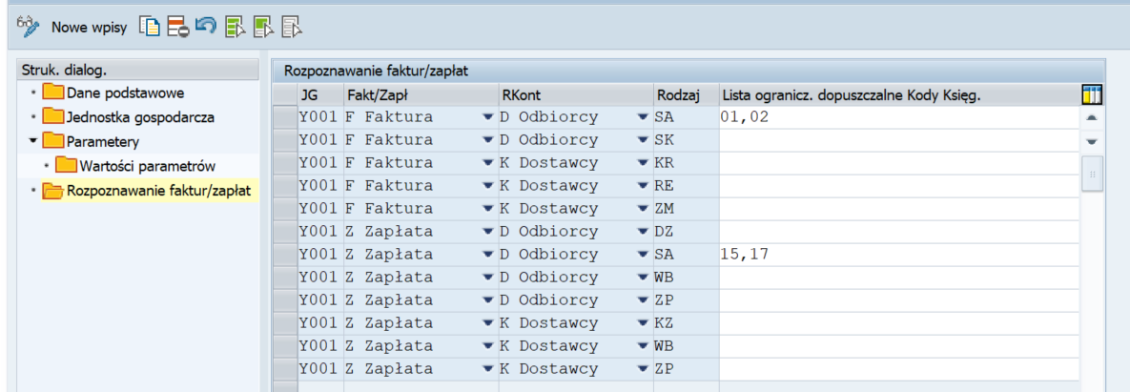
As in example:

Configuration parameters - /n/SNPZP/ZPFC

Validation configuration for the data of the file read from the Excel.
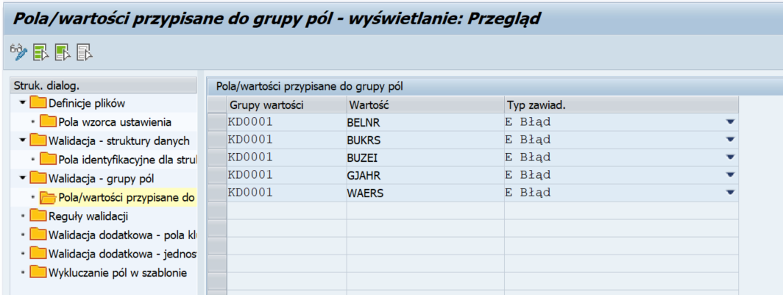
Define the field group.

Define the validation rule for it:

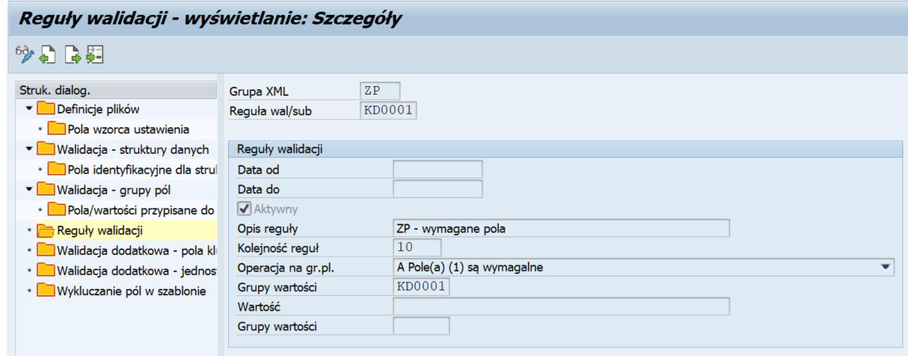
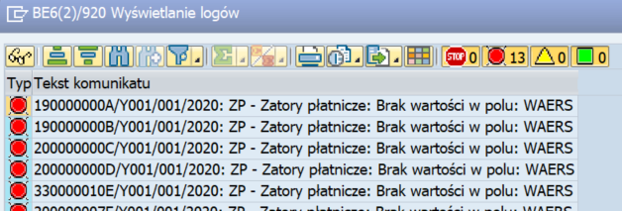
As a results, after importing the file, the user can perform a validation that returns error messages:

Authorization objects

Class/Object

There are four authorization objects managing the access to the various tool functionalities:

- /SNPZP/ZP1 (transaction level/CC)

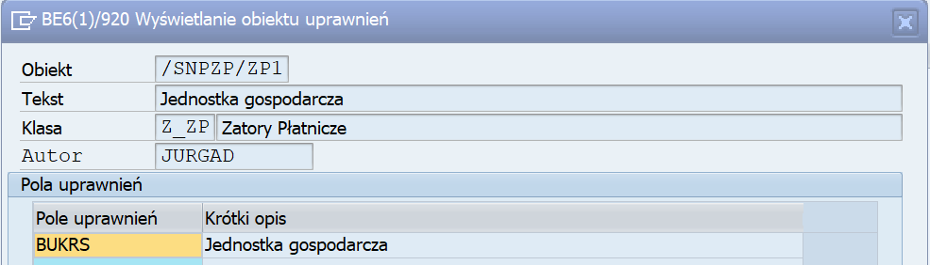

- /SNPZP/ZP2 (CC level/actions within the scope of payment backlogs) – allows to perform the payment backlogs operations defined in the action field.

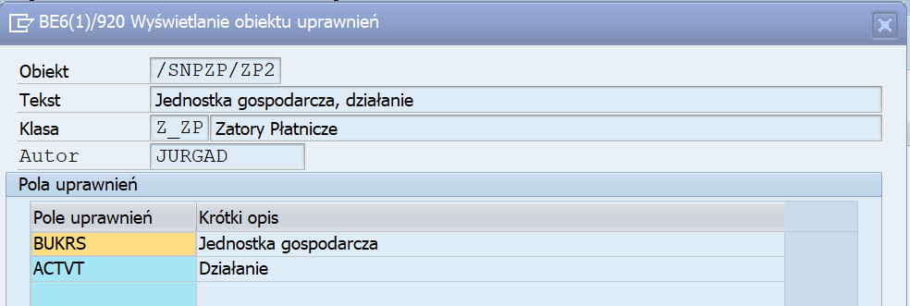

Within this authorization object, it is possible to define a value in the following ranges:

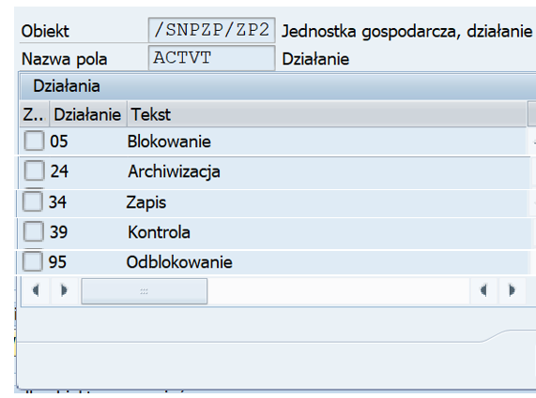

- /SNPZP/ZP3 (CC level/actions within the scope of recipient) – allows to perform the payment backlogs operations defined in the action field and after specified recipients.

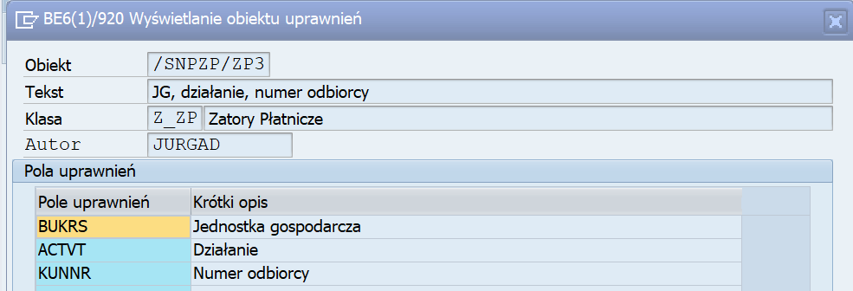

- /SNPZP/ZP4 (CC level/actions within the scope of supplier) – allows to perform the payment backlogs operations defined in the action field and after specified suppliers.

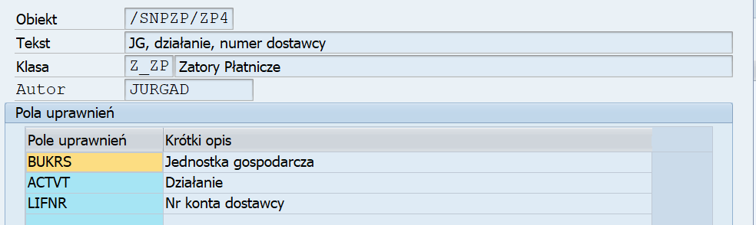

The two last parameters allow to limit the report users to access the data to a specific supplier/recipient group only. It may be crucial when the detailed analysis is necessary (f.i. the data processing validation) by someone who is dealing exclusively with selected contractors.

The correct tool operation requires developing and assigning all four authorization objects to the users.

Transactions and programs

To start the solution, it is required to call up the relevant transaction in the transaction direct call field or select transaction directly from the user role menu.

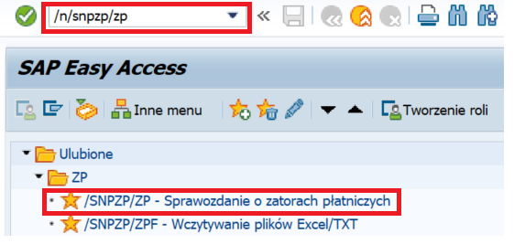

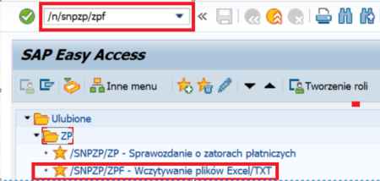

Document selection

Transaction ID | Transaction description
/n/SNPZP/ZP | The Payment backlogs report

In the /SNPZP/ZP transaction user completes the data selection screen.
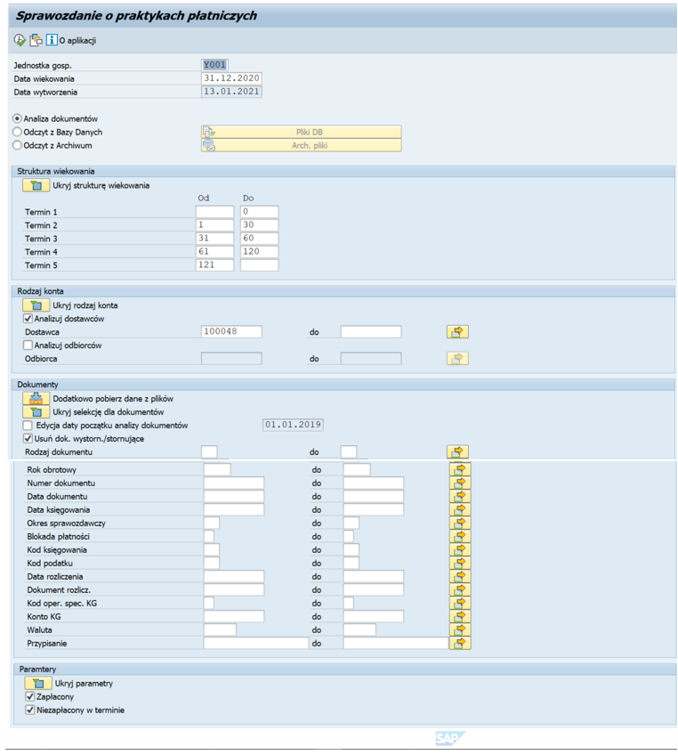

Screen 1 – Headline

- Field name | - Field description | - User action and value | - Comment
Company code | Company code selection | Selection from the list / Manual entry
Aging date | Aging date definition | Selection from the list / Manual entry
Manufacturing date | File creation date definition (today’s default) | Selection from the list / Manual entry
Document analysis | Document analysis for selected period and company code | Selection
Read from database | Data read from the database table (data saved once the document analysis for selected period and company code is finished) | Selection from the list
Read from archive | Data read from the archive (data archived once the document analysis for selected period and company code is finished) | Selection from the list

Screen 2 – Aging structure
Ranges are filled with default values of 30, 60 and 120, but can be freely modified.

Screen 3 – Types of account

- Field name | - Field description | - User action and value | - Comment
Analyze suppliers | Specify the account for supplier/suppliers document analysis | Selection from the list / Manual entry
Analyze recipients | Specify the account for recipient/recipients document analysis | Selection from the list / Manual entry

The user can perform an analysis for individual suppliers/recipients or for the group of them.

Screen 4 – Documents

There is an option to exclude or narrow the document search scope by specifying selected document parameters.

- Field name | - Field description | - User action and value | - Comment
In addition, download data from the files | Retrieve data from imported file/files (previously read files within transactions /n/SNPZP/ZPF) | Selection from the list
Start date of the document analysis change | Positions from the Aging year and from the previous year/years are read from the defined range | Automatic / Manual entry
Document type | Specify document types | Selection from the list / Manual entry
Fiscal year | Specify fiscal year | Manual entry
Document number | Specify document numbers | Manual entry
Document date | Specify document date | Selection from the list / Manual entry
Posting date | Specify posting date | Selection from the list / Manual entry
Reporting period | Specify reporting period | Manual entry
Payment lock | Specify payment codes | Selection from the list / Manual entry
Posting code | Specify the year of the VAT adjustment | Selection from the list / Manual entry
Tax code | Specify document tax codes | Selection from the list / Manual entry
Settlement date | Specify document settlement date | Selection from the list / Manual entry
Billing document | Specify billing documents | Manual entry
GL spec. oper. code | Specify GL special operation code | Selection from the list / Manual entry
GL account | Specify GL accounts | Selection from the list / Manual entry
Currency | Specify documents currency | Selection from the list / Manual entry
Assigning | Specify assigning | Manual entry

Screen 5 – Parameters

The report shall consist of two parts: ‘Paid’ and ‘Unpaid on time’.
For the purposes of the analysis, it is possible to generate each part separately.
- Field name | - Field description | - User action and value | - Comment
Paid | Display paid documents
Unpaid on time | Display unpaid on time documents

The user can hide the structures and use selected parameters that are relevant at the moment the report is generated/
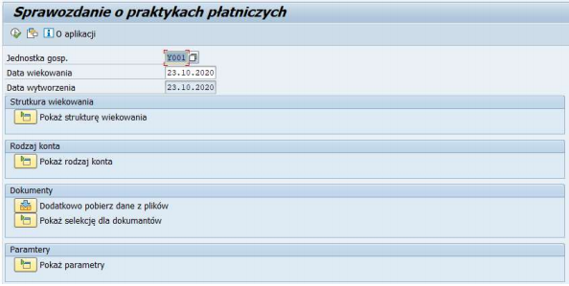

Document analysis
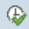
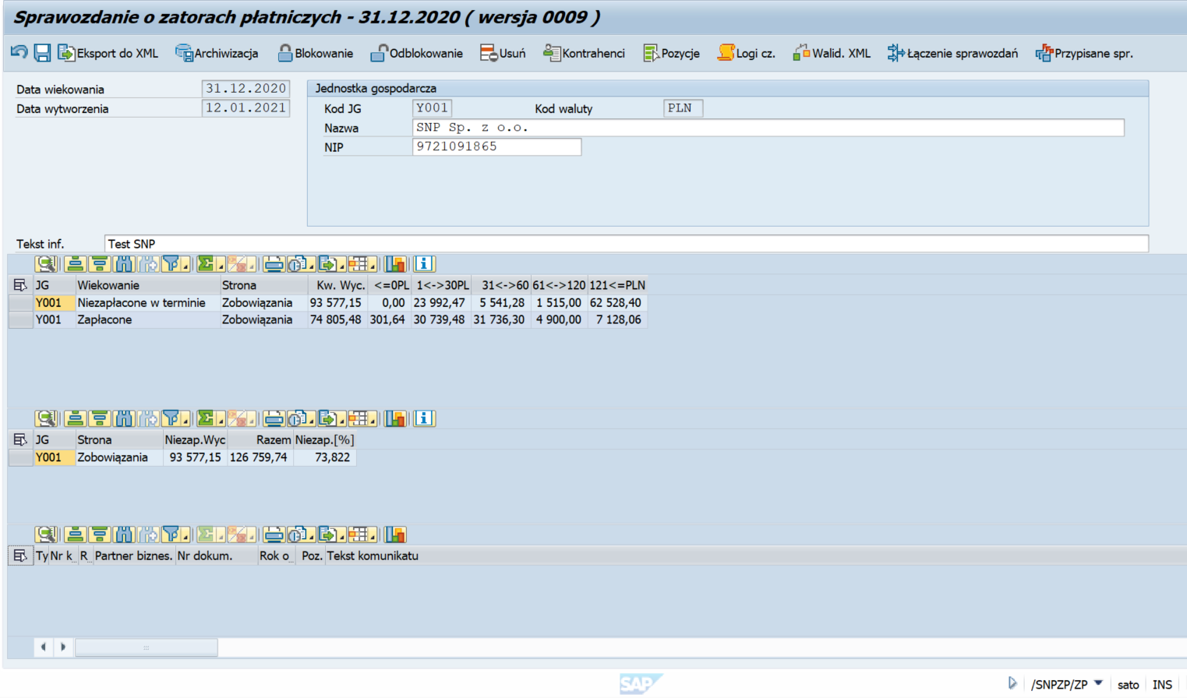
Once the selection screen is completed and the execute icon is selected, the report screen is displayed.

When the Document analysis is chosen on the selection screen, it is possible to change the address data of selected Company code.
In the ‘Tekst. inf.’ field user should type the comment used to describe the generated/saved files.
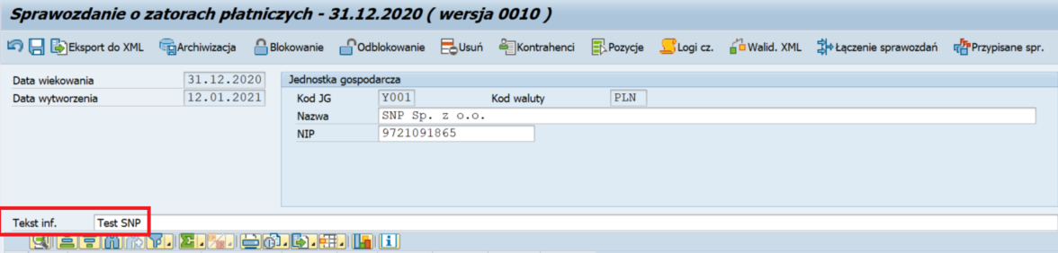

The functional buttons are located at the top of the screen:

- Field name | - Field description | - User action and value | - Comment
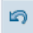 | Undo (F5) | Return to the selection screen.
 | Save to DB (F8) | Save analyzed data to the database table (it can be read, edited and archived later as well as having the option to generate a report file by Read from DB function)
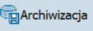 | Archiving (F7) | Save analyzed data to the archive. SAP will delete data from DB tables and save the file to the archive – cannot be edited later, the archived data can be read and the PG file can be generated via Read from PG Archive function | PG – Payment backlogs
 | Locking (Shift+F6) | Block the file changes. Locking occurs automatically when an XML file is generated or at the user request. A user with given permissions can lock generated data before generating into an XML file. The appropriate permissions enable also the read data unlock
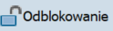 | Unlocking (Shift+F7)
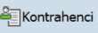 | Contractors (Ctrl+Shift+F1) | Display all contractors in the analyzed file
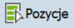 | Positions (Shift+F11) | Display all single positions in the analyzed file
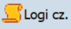 | Activity logs (Shift + F1) | Review the processes performed for the specific report file type (for a given date range and the report file version)
 | Statements conjunction (Ctrl+F4) | A function to combine the supplier and recipient reports into a single file
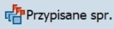 | Assigning backlogs statement (Ctrl+F7) | Reports combined with the current report

The screen is divided into three sections – ‘Values’, ‘Percentage values’ (the ‘Percentage values’ are the percentage of documents not paid by the due date for all documents that should be paid in a given year) and ‘Messages’ – identified incompatibilities with the report assumptions.
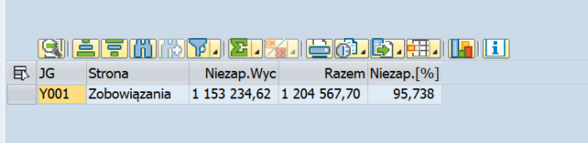

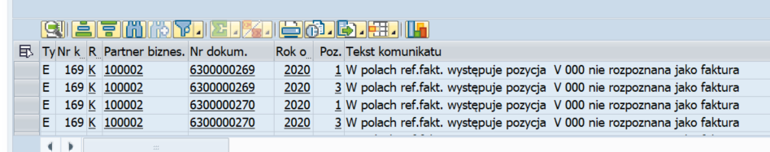

The ‘Values’ section shows the division of one report into two reports: ‘Unpaid on time’ and ‘Paid’.

Unpaid on time – documents that have not been paid by the aging date and documents paid but at a different date from the due date. In the solution, the user checks the payment dates on the document relative to the payment/settlement date.

Paid – the report shall show all documents that have been paid/settled in the year to which the report applies: f.e., if generating the report for 2020, this report will show all documents settled in 2020.

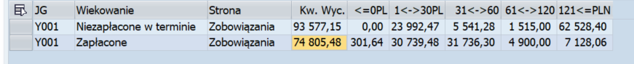
The Reports can be analyzed. For example, select the report ‘Paid’:

The double-click on any field will redirect to the suppliers/supplier list, f.e. ‘Kw. Wyc.’.
Next, the double-click on the selected field with supplier position allows to display the list of documents in the ALV layout:
Attention: By clicking on the selected range (<=0PLN-121<=PLN), the items that make up the sum of this range are displayed.

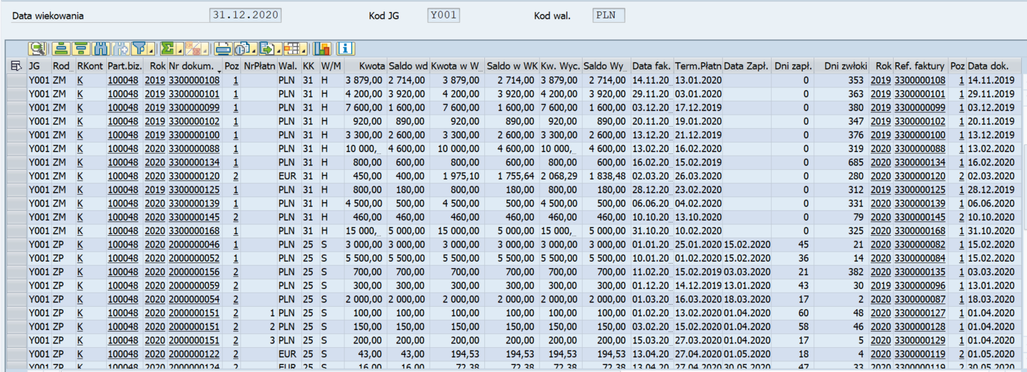
The ALV layout:

Important information about the report:
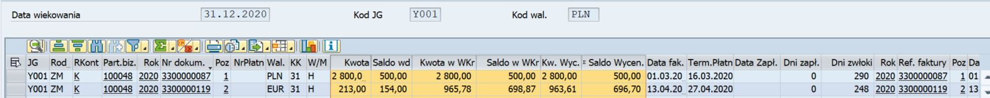
- In the report, the invoice item contains the original amount from the document and is displayed in the ‘Amount/Kwota’ column, meanwhile in the ‘Balance/Saldo’ column the report shows the amount reduced by payments made (and possible corrections), recognized in this invoice.

- The ‘Amount‘ and ‘Balance‘ are the basis for any billing in the report,
- The ‘Kwota w Wkr‘ and ‘Saldo w Wkr‘ are the Amount and Balance in the national currency,
- The ‘Kw.Wyc.‘ and ‘Saldo Wycen.‘ are calculated according to the rules defined by the Ministry of Finance in PLN in the due date rate (due for payment).

The rules for calculating reported values in the report:
‘Kwota‘ -> settlement: ‘Saldo wd‘
‘Saldo wd‘ -> conversion: ‘Saldo wyceny‘

In the summaries (total and for the contractor) there is a transition:
‘Saldo wyceny’ (position) -> ‘Kwota wyceny’ (summary)

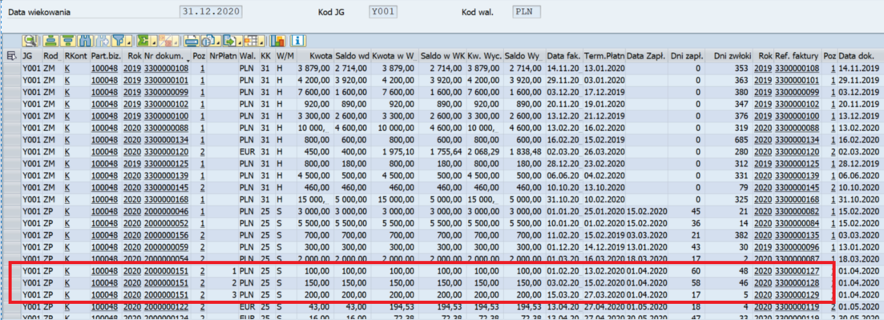
In the report the payment item contains the full amount, unless the payment is split into different invoices, then the amount is appropriately divided into separate items in the report.

The payment indicates the invoice associated with it (for information purposes only, such direct relation is normally not defined in the system). The relation key consists of the ‘Year’ + ‘Invoice ref.’ + ‘Item’ columns.

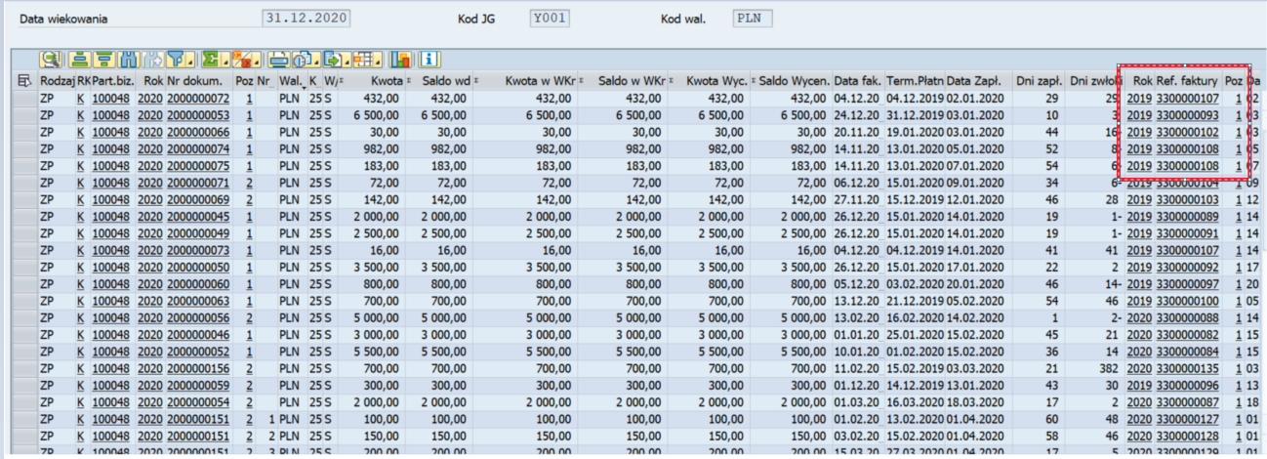
The double-click on the selected document allows to navigate to document details or the supplier data:
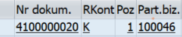

Tools are available above the list of documents to assist with the analysis (the SAP standard):
The user can create his own data display variant, such as layout, which can be used then to import data from a file (the /snpzp/zpf transaction which is discussed later in this manual):
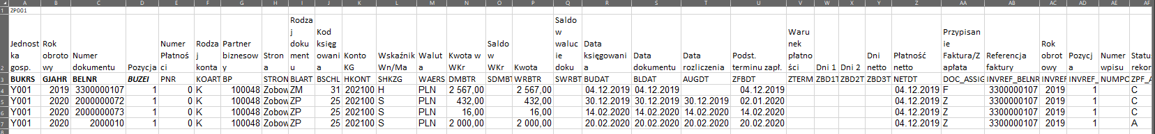

Save to database

The analyzed report data should be saved to database. The saved databases are locked for editing by default. To save the file to database, the user has to select the save button from the program menu.

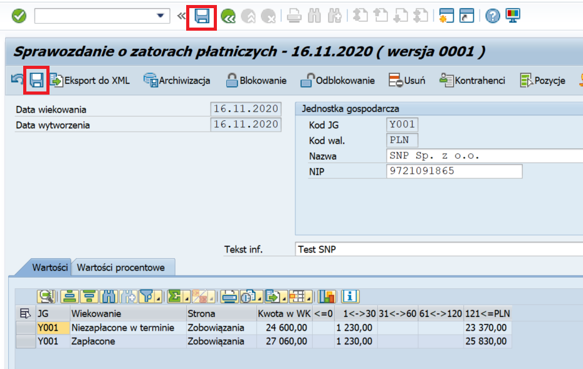

Statements conjunction

The generation of the report shall be done separately for suppliers and recipients. Once the report is generated (f.e., for suppliers), the file should be saved to database. Then the report for the recipients is generated and it can be combined with the suppliers report after analyzing the documents.
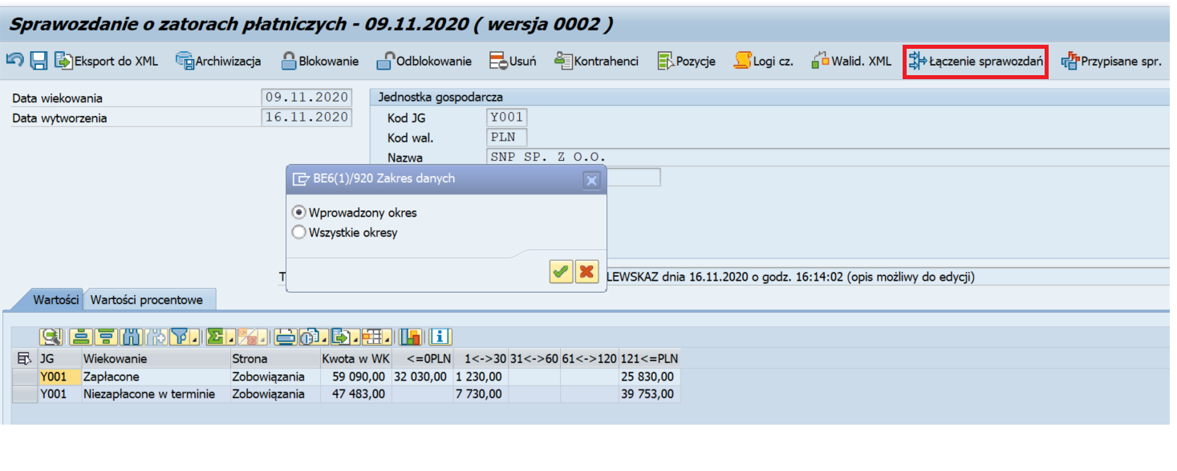
Select the data period, f.e.: ‘Selected period’
The list of files stored in the DB is displayed.
Select the file, f.e.: ‘Test SNP’
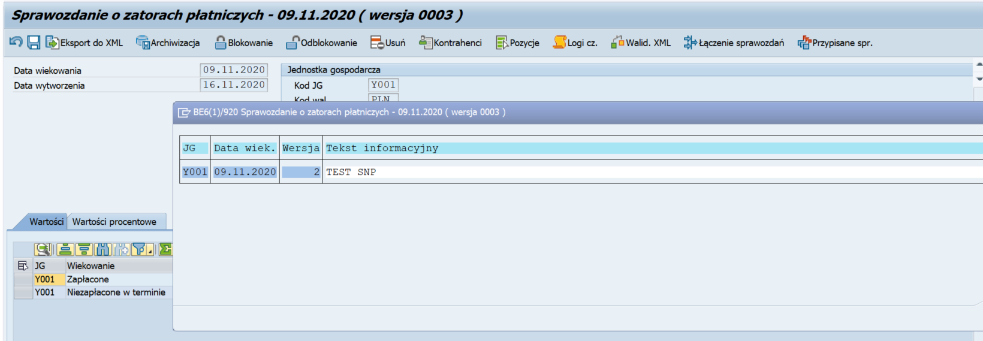

The following message is displayed:
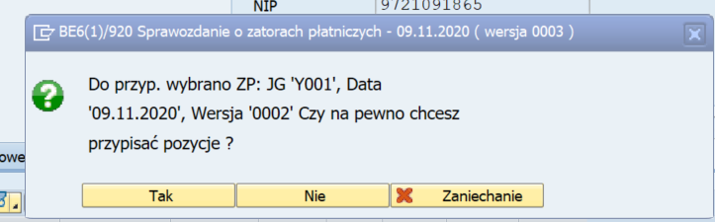

Confirm.
The data has been merged.

Loading Excel/TXT files

Transaction ID | Transaction description
/n/SNPZP/ZPF | The Excel files management

Integration with Excel extends the functionality of the core Payment backlogs report package.
It allows, in particular, to:
- attach/add the additional data by loading additional data provided as files,
- correct and delete documents (or document items) from SAP system.

To load files, use the /SNPZP/ZPF transaction.

Once the /SNPZP/ZPF transaction is started, the selection screen is displayed and the limits for the files that are read and viewed have to be specified.
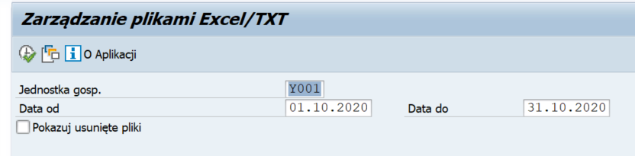

- Field name | - Field description | - User action and value | - Comment
Company code | Select the Company code | Selection from the list / Manual entry
Date from-to | Specify period | Selection from the list / Manual entry

Once the input parameters have been validated, the file loading management screen appears:
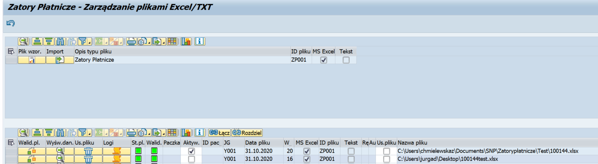

At the top of the screen, the button on the left allows to generate a blank data file:
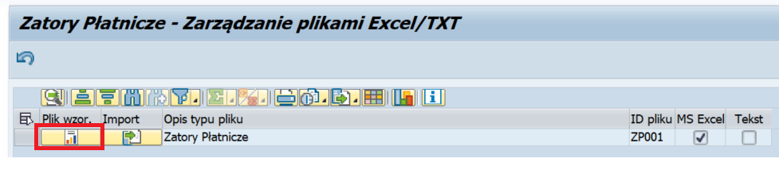

Important! The model text/Excel files, in addition to the columns specific to the report, contain the specific column ‘The record status/Status rekordu’ (ZJPF_ACTION). This column can be left blank if a record is to be added to the report (the same action will result in an ‘A’ value in this column). The ‘Status record/Status rekordu’ column can be used to select the action to be performed for a given record. There is a complete list of possible values in the following table:

- Record status value | - Name | - Operation description
A | Record added from file | As in the example above: Adds a new record
C | Record changed from file | Change header record and the position added by the basic solution in SAP. Document/item numbers should be the same as in the modified document. Only the fields for which the user has entered a value will be changed.
D | Record to delete | Delete record (header or item) added to the report by the basic solution. The document/item numer should match the document to be changed. Values in fields other than ‘Record status/status rekordu’ and document number are not relevant.
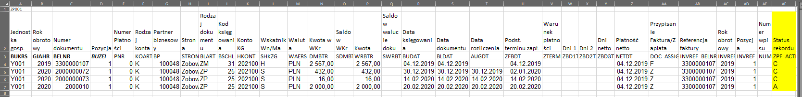
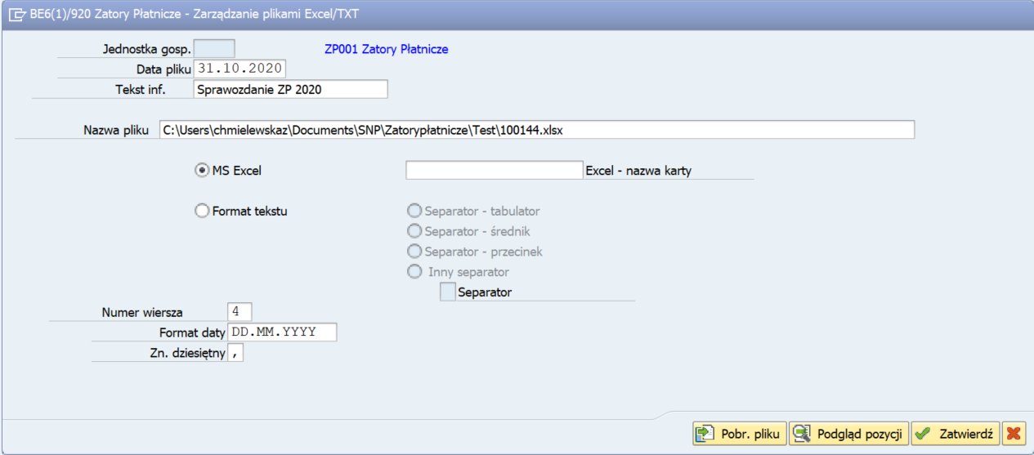
The next buton (‘Import data’) allows to load the file:

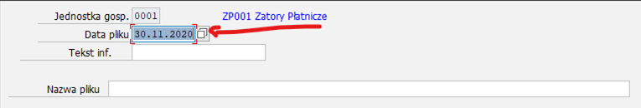
The files are loaded in the following steps:
- data file completion (enter file date – the end of range appears as default date in file date, file description and file selection only),
- file download (button),
- loaded file items view (button, the optional step),
- file load confirmation pliku (button).

The file loading can be stopped at any time by pressing the cancel key.

When the properly loaded file is approved, it appears in the loaded files list at the top of the management screen:
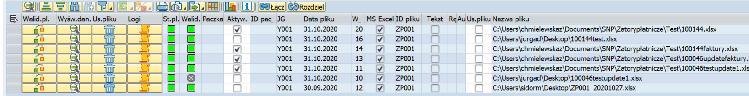

For each file, the validation can be performer with the ‘File validation’ button on the left. Validation is not mandatory but recommended, as data errors may be detected during validation. Attention: A negative validation does not prevent the file from being loaded (there are situations where the user wants to load a file even if the validation was not successful).

Each loaded file can be displayed with the next ‘Data display’ key. The button with a trash can icon allows to delete previously loaded file. The next key gives an overview of the logs associated with the file.

The loaded file activation: activate the loaded file directly by checking the ‘Activation’ check box – without activation, he data will not be available for loading in the report.

Active files can be uploaded to the Payment practices report using the /SNPZP/ZP transaction.

In the /SNPZP/ZP transaction, on the ‘Documents’ screen, there should be selected the ‘Download data from files additionally/Dodatkowo pobierz dane z plików’ button:

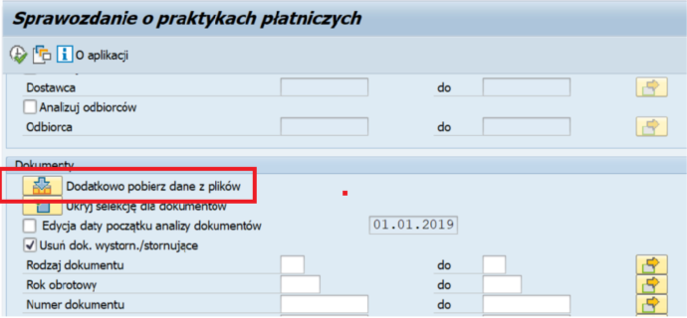

next should be selected Check box for the file or files from which the user wants to import data into the report:

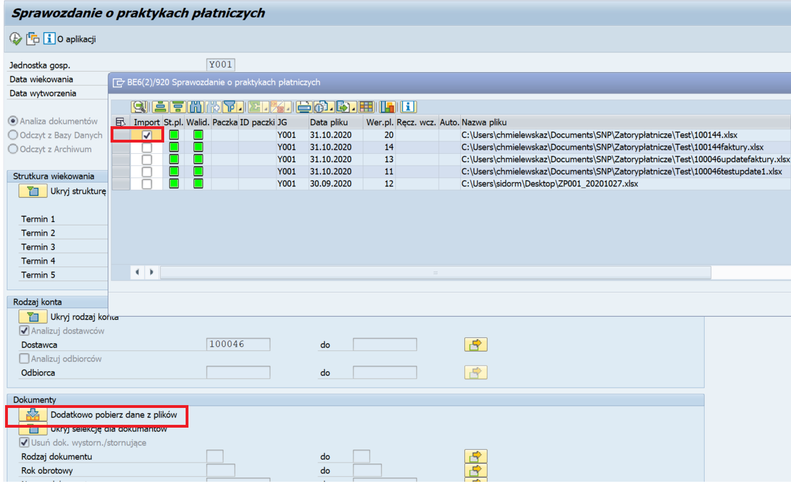

Combining data from files. The file rows to be combined should be selected with the ‘Combine files/Łącz’ button clicked. The process of verifying and merging data into a package will begin.
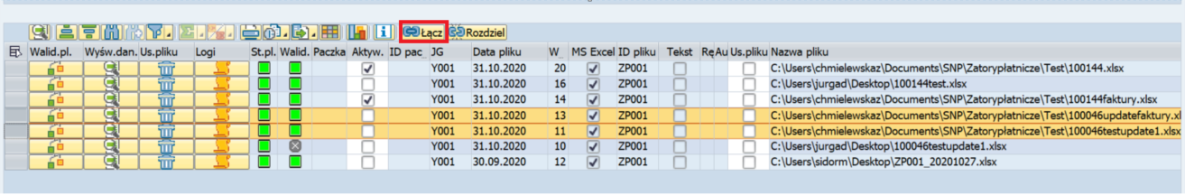

When the data is successfully linked to the files, a ‘package’ ID will be assigned to the files, at which the chain icon appears to have the files correctly combined with the package:

Linked files must be activate manually. Only active files are available from the report creation transaction side (the /SNPZP/ZP transaction).

Tips & Tricks
The /SNPZP/ZP transaction can read the value selection options (templates) on the selection screen.

Variants are created by filling in the relevant fields in the selection screen for which the user wants to create the variant (save the entered values as a variant/template for later use), and then selecting the save icon (or use the Ctrl + S key combination).


