All for One Poland Services
CloudDC.eu Certificate update 2026
Version 04.11.2026

Version | Person responsible | Comment
04.11.2026 |  | Updated 2026 certificate
03.11.2025 |  | Created

Table of Contents
1 Description and Certificate file 3
2 Certificate update SAP 3
3 Certificate update PO/PI/CPI 5

Description and Certificate file
Necessary update for clouddc.eu certificate. New certificates will be valid from 18.11.2026 to May 2027. Please take note that before this date All for One Poland services will be using old certificates. Certificate must be updated in SAP for direct connections or PO/PI/CPI side if they are used for communications with All for One Poland’s services.
Root and intermediate certificates are unchanged
In some SAP systems root/ intermediate certificates are sufficient.
Certificate is used in services for products:
- OneAPI
- KSeF
- JPK Transfer HUB
- Partner Checker
- Partner Checker Direct connection
Valid from | Certificate
18.11.2026

Certificate update SAP
You need to import the OneAPI gateway server certificates into the trusted certificates list for the PSE container: SSL Client (Standard), file: SAPSSLC.pse
For the direct connection from SAP, certificate import is performed in the STRUST transaction for the PSE container: SSL Client (Standard).
Please take note that according to system configuration update needs to be performed in other containers, fro example SSL Client (Anonymous)
If connecting via a proxy or PO, certificates must be added on the corresponding system that connects to the OneAPI service.
Step1. Go to STRUST. Select proper container and select edit mode and select import certificate.
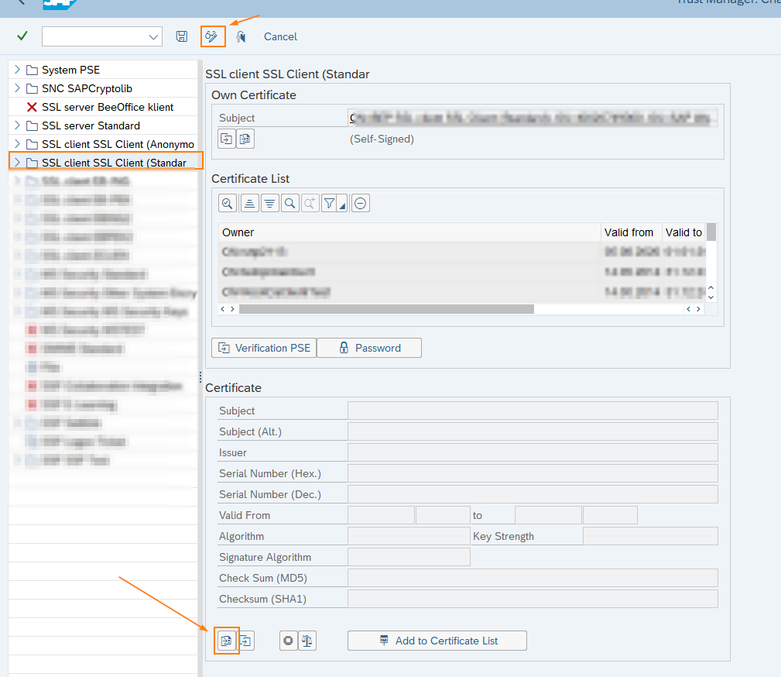
Step 2. Select certificate file and select “Add to Certificate List
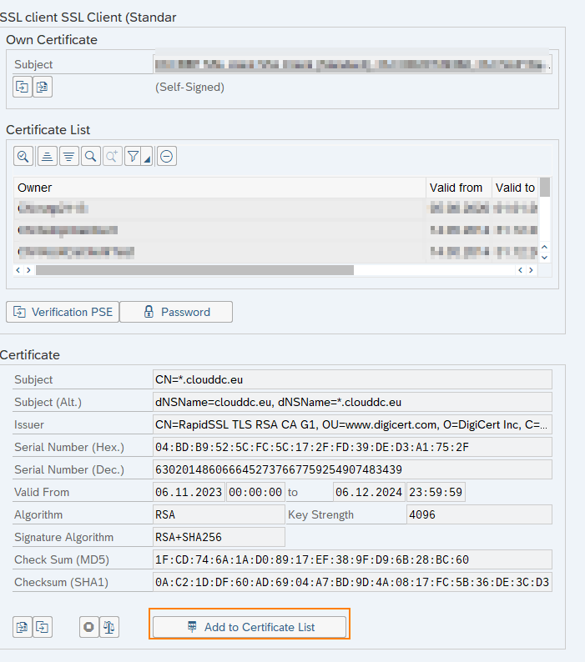
Step 3. Save changes.
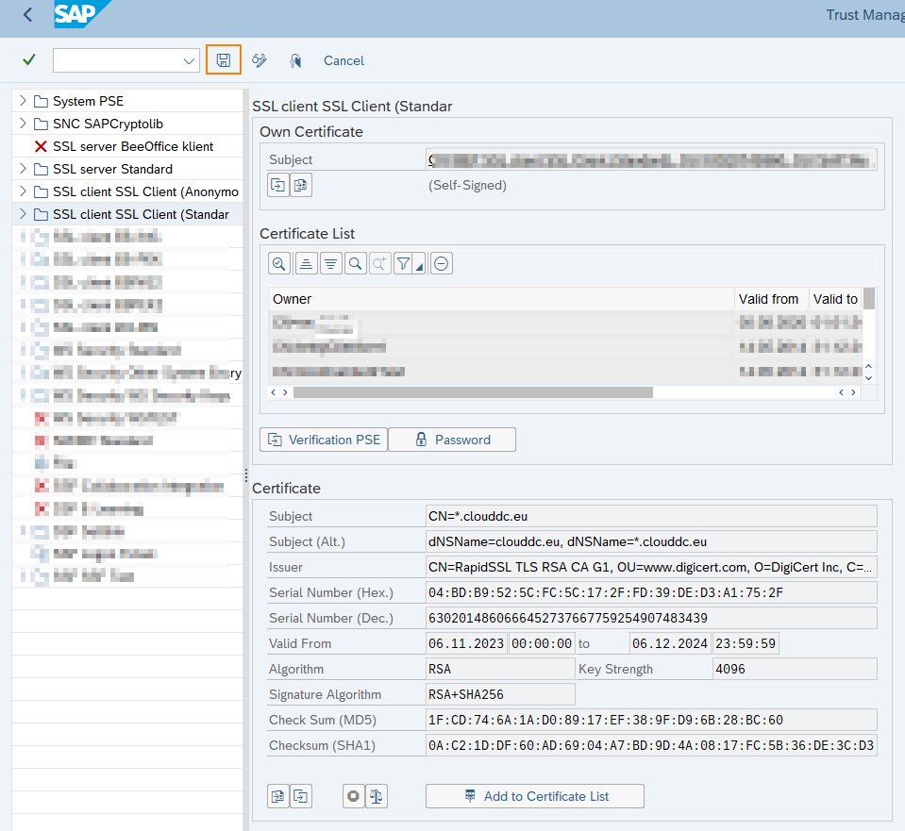

Certificate update PO/PI/CPI
According to the chosen connection scenario it is required to update certificates on PO/PI/CPI side also.
You need to import the OneAPI gateway server certificates into the trusted certificates list for the Trusted CAs in SAP NetWeaver Administrator.
Step 1: Go to SAP NetWeaver start panel (/dir/start/index.jsp) and choose Administrator option.
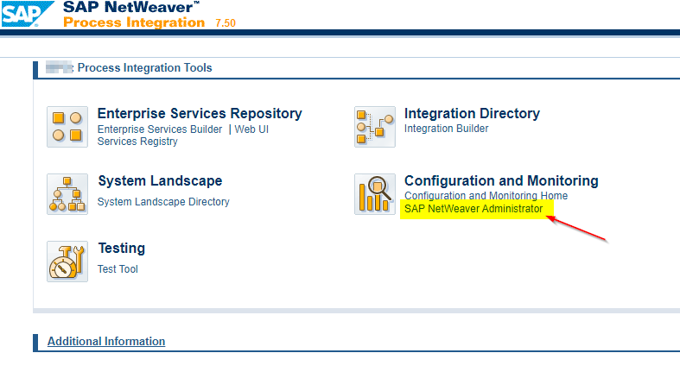

Step 2: Go to “Certificates and Keys”:
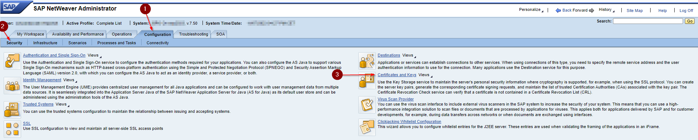

Step 3: Find “TrustedCAs”, and then look for certificates’ status there. You can also filter your search by name. Then to import click “Import Entry”:
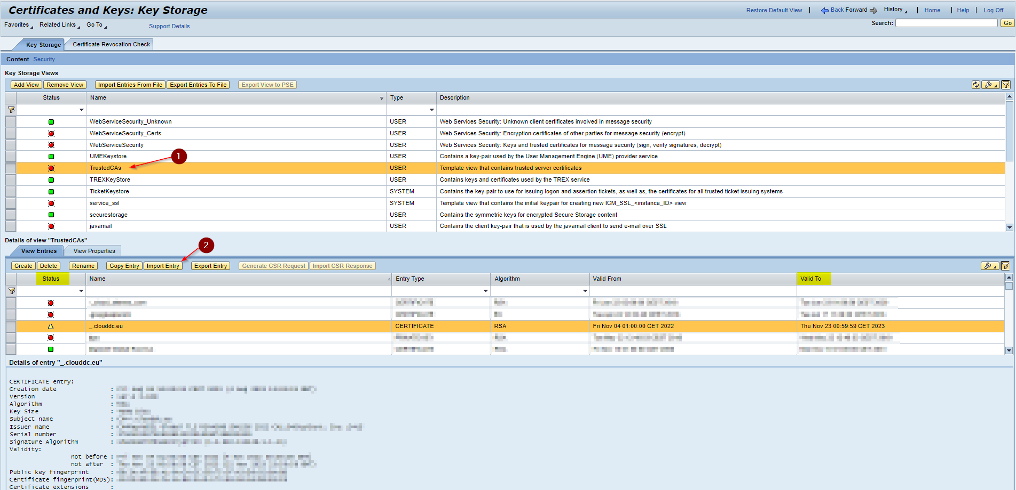

WARNING: You can see 3 icons there (green - valid, yellow - soon to expire and red - expired). Never remove or change (without technical knowledge of the product) certificates with green or yellow icons!
Step 4: Upload all new or delivered certificates. Choose type X.509 with extension “.crt” or “.cer”:


